**Module: 14- Identity with Windows Server**

**31. Installing and Configuring Hyper-V Virtualization in Windows Server 2016:**

Hyper-V is a virtualization platform in Windows Server.

Installation Steps:

Enable the Hyper-V role via Server Manager.

Create virtual machines (VMs) using Hyper-V Manager.

Configure VM settings, including memory, storage, and networking.

Steps:

Install the Hyper-V Role:

Open Server Manager.

Click Add Roles and Features.

Choose Role-based or feature-based installation.

Select the Hyper-V role.

Install the role and include management tools1.

Create a Hyper-V Virtual Machine:

Open Hyper-V Manager.

Right-click the Hyper-V host and select New > Virtual Machine.

Follow the wizard:

Specify the VM name.

Choose the default path or customize the storage location.

Select the VM generation (Generation 1 for compatibility, Generation 2 for UEFI features).

Configure memory, network, and other settings2.

Install an Operating System on the VM:

Attach an ISO or bootable image to the VM.

Start the VM and install the OS.

Configure Networking:

Create a virtual switch in Hyper-V Manager.

Connect the VM to the virtual switch.

Manage VMs:

Use Hyper-V Manager to start, stop, and manage VMs.

Monitor performance and adjust settings as needed.

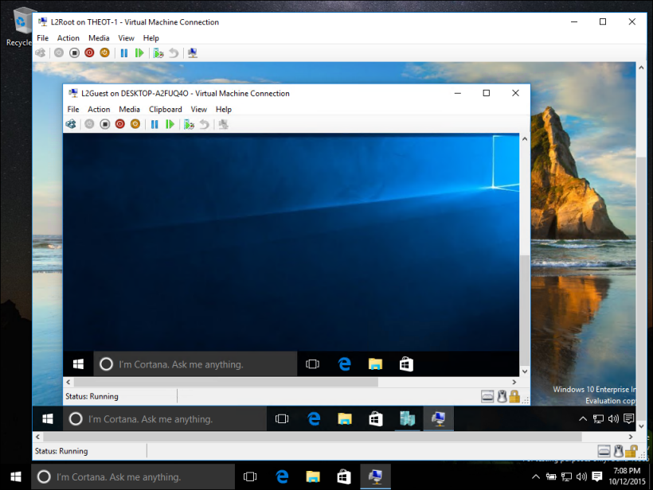

**32. Monitoring Server Performance and Managing Event Logs:**

Use tools like Task Manager, Resource Monitor, and Performance Monitor.

View event logs in Event Viewer for system health and troubleshooting.

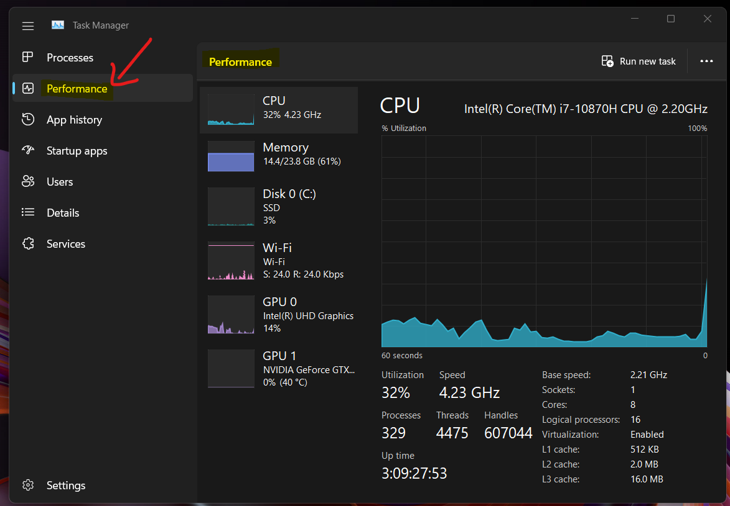

**33. Types of Storage Options in Windows Server:**

Direct-Attached Storage (DAS): Local disks directly connected to the server.

Network-Attached Storage (NAS): Shared storage accessible over the network.

Storage Area Networks (SAN): High-performance, dedicated storage networks.

Cloud Storage: Storing data in cloud services like Azure or AWS.

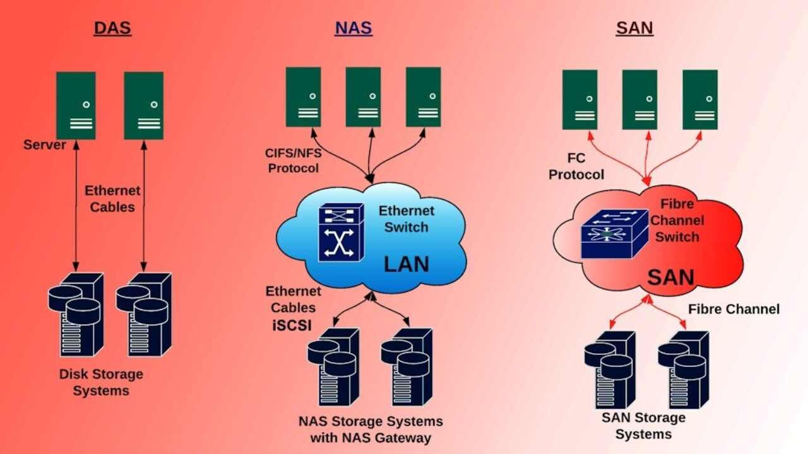

**34. Role of File Server in Windows Server:**

The File Server role in Windows Server plays a crucial role in centralizing storage and managing data files. Here’s a brief overview:

Role Description:

A File Server provides central locations on your network where you can store files and share them with users.

It enables administrators to set up and manage multiple file servers and their storage capabilities.

Practical Applications:

Storage Spaces: Deploy high-availability storage using cost-effective industry-standard disks.

Folder Redirection, Offline Files, and Roaming User Profiles: Redirect local folders or entire user profiles to a network location while caching contents locally for speed and availability

File Server hosts shared files and folders for users.

Configuration Steps:

Install the File Server role.

Create shared folders with appropriate permissions.

Install the File Server Role:

Open Server Manager.

Click Add Roles and Features.

Choose File Server in the Server role selection.

Follow the wizard to complete the installation1.

Create Shared Folders:

Open File Explorer.

Right-click on a folder you want to share.

Select Properties > Sharing > Advanced Sharing.

Click Share this folder and set permissions for users2.

Configure Disk Quotas (Optional):

To control disk space usage, set up disk quotas:

Open Server Manager.

Go to File and Storage Services > Shares.

Right-click the shared folder and choose Properties.

Configure quotas on the Quota tab1.

Test Access:

Access the shared folder from other computers on the network.

Ensure users can read, write, and manage files.

**35. Implementing and Managing Distributed File System (DFS):**

DFS organizes distributed file shares into a unified namespace.

Steps:

Install DFS role.

Configure namespaces and replication groups.

Provide redundancy and location transparency for file access.

DFS is a powerful feature that allows you to organize and replicate file shares across multiple servers. Here are the steps:

Install DFS Roles:

Open Server Manager on your Windows Server 2016 machine.

Click Manage in the top-right corner, then select Add Roles and Features.

Expand File and Storage Services, and choose File Server, DFS Namespaces, DFS Replication, and File Server Resource Manager (optional but recommended for replication).

Install the selected roles.

Configure DFS Namespace:

Open DFS Management from the tools menu in Server Manager.

In the left pane, right-click on Namespace and choose New Namespace.

Specify a name for the namespace (e.g., “CorpDocs”).

Set permissions (e.g., “Administrators have full access; other users have read and write permissions”).

Click Next to create the namespace.

Create Shared Folders:

Add shared folders to your server (e.g., “CompanyDocs”).

These folders will be part of your DFS namespace.

Add Folder Targets:

Right-click on the namespace you created and choose New Folder.

Specify the folder name (e.g., “SharedDocs”).

Add the server paths (folder targets) where the data resides (e.g., \Server1\CompanyDocs, \Server2\CompanyDocs).

Test Access and Replication:

Access the shared folder using the DFS namespace path (e.g., \Domain\CorpDocs\SharedDocs).

Verify that files are accessible.

If using DFS Replication, ensure files are synchronized between servers.

**36.Built-in Backup and Recovery Options in Windows Server 2016/2019:**

Windows Server Backup (WSB):

Purpose: Basic data protection solution included in Windows Server.

Features:

Full server backup (bare metal recovery).

Individual file and folder backups.

Remote server backups.

System State backup.

Configuration:

Install the Windows Server Backup feature.

Configure backup settings, including the backup destination (e.g., a remote shared folder).

Restore:

Use the Windows Server Backup tool to restore files, folders, or the entire server.

Troubleshooting Startup Issues:

Last Known Good Configuration:

Start the computer with the most recent working settings.

Useful after incorrect driver installations or other changes.

Windows Recovery Environment (WinRE):

Boot from the Windows Server installation DVD.

Access WinRE tools for diagnostics and repairs.

**37. Configuring Windows Server Backup for Critical Data:**

To set up Windows Server Backup for critical data, follow these steps:

Install Windows Server Backup Feature:

Open Server Manager.

Click Add roles and features.

Select Windows Server Backup under features and install it.

Configure Backup:

Open Server Manager.

Click Tools > Windows Server Backup.

Choose Backup Once or Backup Schedule.

Select Full server (recommended) to back up all data, applications, and system state.

Specify a remote shared folder as the backup destination.

Provide credentials for write access to the shared network folder.

Confirm and start the backup process.

**38. Restoring Files and Folders using Windows Server Backup:**

To restore files and folders from a previous backup:

Open Server Manager.

Go to Tools > Windows Server Backup.

Select Local Backup on the left and click Recover on the right.

Choose the backup location and date.

Select the recovery type (e.g., “Files or Folders”).

Specify the location for system state recovery (usually leave it as the original location).

Select the files or folders to restore.

Configure recovery options.

Click Recover to restore the selected data.

**39. Troubleshooting Windows Server Startup Issues:**

If your server encounters startup problems, consider these steps:

Last Known Good Configuration:

Use this feature to start the computer with the most recent settings that worked.

It restores registry information and driver settings from the last successful startup.

Helpful after installing incorrect drivers or making other changes.

Windows Recovery Environment (WinRE):

Boot from the Windows Server installation DVD.

Choose Repair your computer > Troubleshoot > Command Prompt.

Use WinRE tools for diagnostics and repairs.

**40. Troubleshooting Network Connectivity in Windows Server:**

Network connectivity issues can impact server performance and reliability. Here are some steps to troubleshoot:

Test-NetConnection:

Use the Test-NetConnection PowerShell cmdlet to diagnose connectivity problems.

Check DNS resolution, ping, and route tracing.

Enable TCP port testing for specific services.

Check DNS Configuration:

Verify DNS settings on the server.

Ensure proper DNS resolution for Active Directory communication.

Verify Network Switches and VLANs:

Collaborate with network engineers to validate switch configurations.

Ensure VLAN settings are correct.

**41. Common Active Directory Issues and Troubleshooting:**

Active Directory (AD) is critical for authentication and authorization. Here are common issues and solutions:

Domain Join Problems:

Verify user credentials and account status.

Check DNS settings and firewall rules.

Ensure time synchronization.

Replication Issues:

Use tools like Repadmin to monitor and troubleshoot replication.

Address DNS, connectivity, and security issues.

Performance Bottlenecks:

Monitor domain controllers using Performance Monitor (perfmon.exe).

Optimize hardware resources (CPU, memory, disk).

**42. Troubleshooting Performance Problems on Windows Server:**

Performance issues can impact user experience. Consider the following:

TCP/IP Known Issues:

Address slow throughput on high/low latency networks.

Enable TCP Window Scale and Receive Side Scaling (RSS).

Windows Server Monitoring Tools:

Use built-in tools like Task Manager, Resource Monitor, and Performance Monitor.

Monitor CPU, memory, disk, and network utilization.